Ex.no:5b | DATA VISUALIZATION USING MATPLOTLIB –  SALES DATA

AIM
To visualize and analyze the Hotel Booking Demand, Customer Behavior and Cancellation Analysis dataset using Line Chart, Bar Chart, and Pie Chart with Matplotlib to understand booking trends, hotel-type comparisons, and market segment distribution.

ALGORITHM
Step 1: Import Pandas and Matplotlib libraries.
Step 2: Load the Hotel Booking Demand dataset into a DataFrame.
Step 3: Group the hotel bookings according to arrival year and calculate the number of bookings for each year.
Step 4: Plot the yearly booking count using a Line Chart to observe the trend of hotel bookings over time.
Step 5: Group the dataset according to hotel type and calculate the number of bookings for each hotel.
Step 6: Plot the hotel booking counts using a Bar Chart to compare bookings across different hotel types.
Step 7: Select the major market segments and calculate their booking proportions.
Step 8: Plot the market segment distribution using a Pie Chart.
Step 9: Add suitable titles, axis labels, legends, and display the visualizations.

CODE
import pandas as pd
import os
import kagglehub
import matplotlib.pyplot as plt

# Download latest version
path = kagglehub.dataset_download("jessemostipak/hotel-booking-demand")

print("Path to dataset files:", path)

# Load the hotel booking dataset already downloaded using kagglehub
csv_file = [f for f in os.listdir(path) if f.endswith(".csv")][0]

df = pd.read_csv(
os.path.join(path, csv_file),
encoding="latin1",
low_memory=False
)

# --------------------------------
# 1. Histogram – Average Daily Rate
# --------------------------------

plt.figure(figsize=(10, 5))

plt.hist(
df["adr"].dropna(),
bins=30
)

plt.title("Distribution of Average Daily Rate")
plt.xlabel("Average Daily Rate (ADR)")
plt.ylabel("Frequency")

plt.show()

# --------------------------------
# 2. Scatter Plot – Lead Time vs ADR
# --------------------------------

plt.figure(figsize=(10, 5))

plt.scatter(
df["lead_time"],
df["adr"],
alpha=0.5
)

plt.title("Relationship Between Lead Time and Average Daily Rate")
plt.xlabel("Lead Time")
plt.ylabel("Average Daily Rate (ADR)")

plt.show()

# --------------------------------
# 3. Box Plot – Average Daily Rate
# --------------------------------

plt.figure(figsize=(8, 5))

plt.boxplot(
df["adr"].dropna()
)

plt.title("Box Plot of Average Daily Rate")
plt.ylabel("Average Daily Rate (ADR)")

plt.show()

OUTPUT
Using Colab cache for faster access to the 'hotel-booking-demand' dataset.
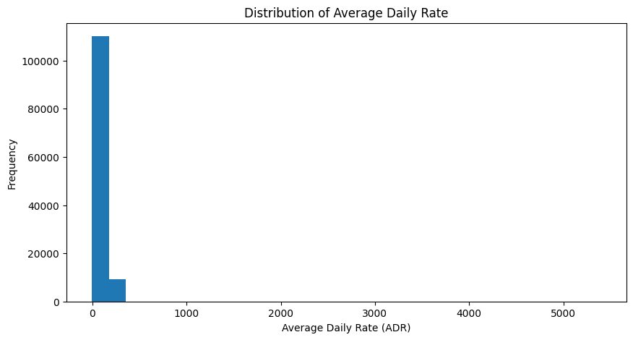
Path to dataset files: /kaggle/input/hotel-booking-demand

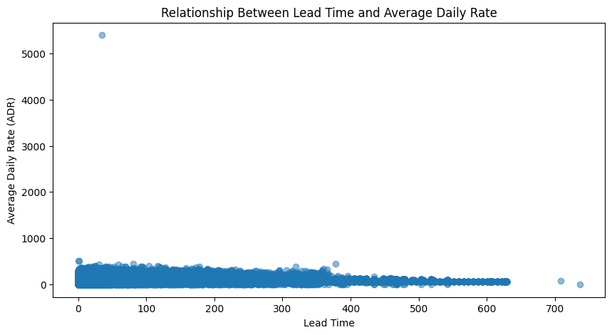

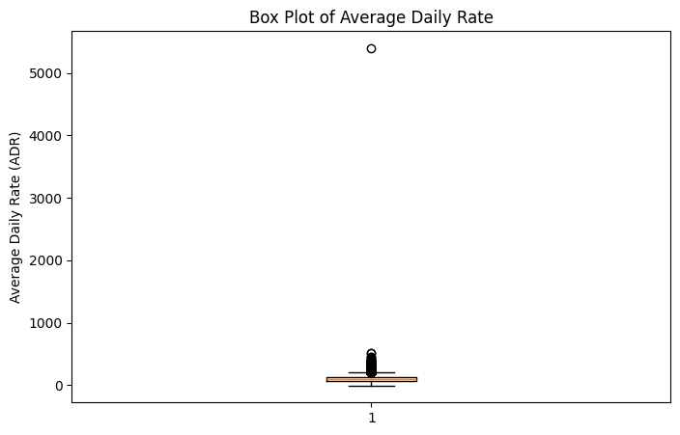

RESULT

